Output:

A1

(a)

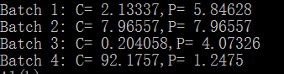

(b)

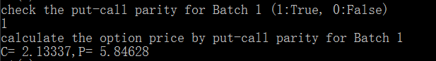

(c) T = 0.25, K = 65, sig = 0.30, r = 0.08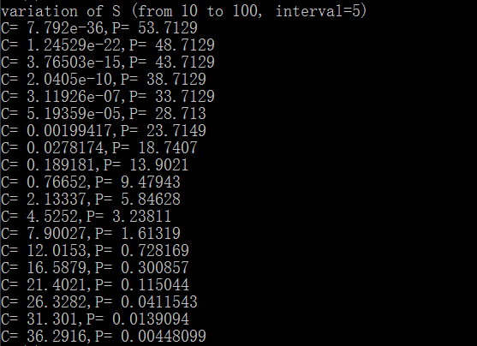

(d) T = 0.25, K = 65, sig = 0.30, r = 0.08, S = 60

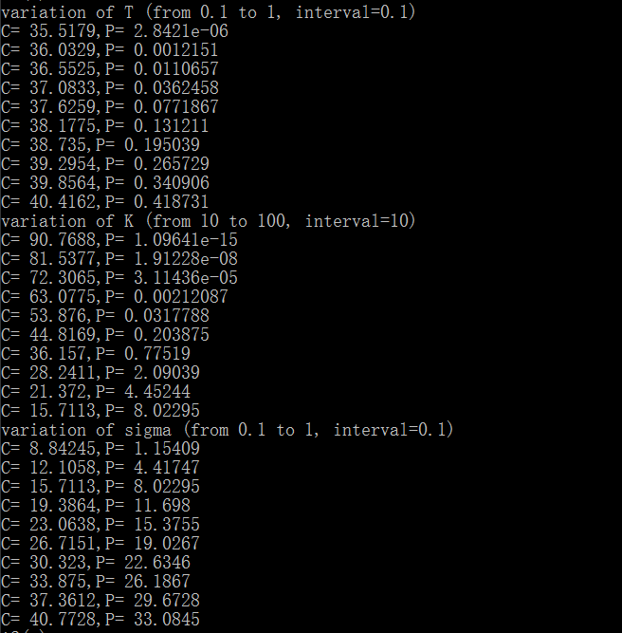

A2

(a)



(b) K = 100, T = 0.5, r = 0.1, b = 0, sig = 0.36.

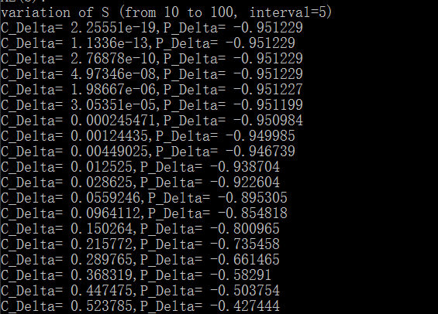

(c)

Delta: K = 100, S = 105, T = 0.5, r = 0.1, b = 0,sig = 0.36.

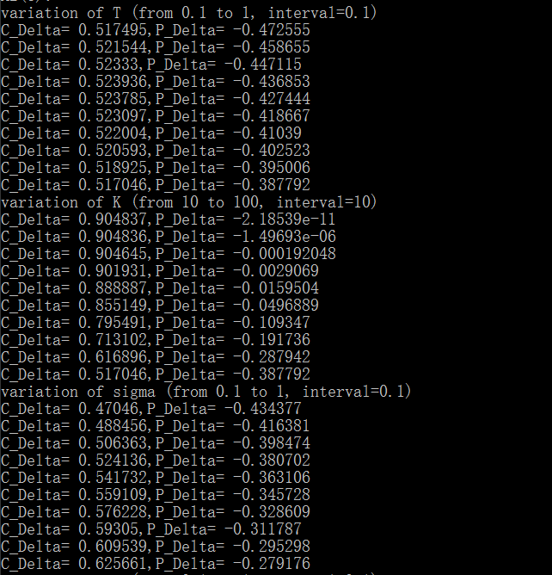

Gamma: K = 100, S = 105, T = 0.5, r = 0.1, b = 0,sig = 0.36.

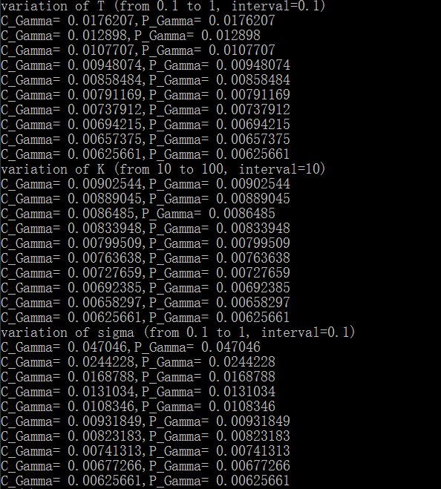

(d) K = 100, S = 105, T = 0.5, r = 0.1, b = 0,sig = 0.36.

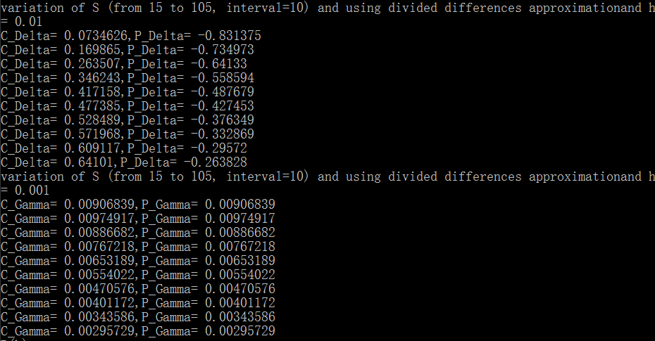

B

(b)



(c) K = 100, sig = 0.1, r = 0.1, b = 0.02, S = 110

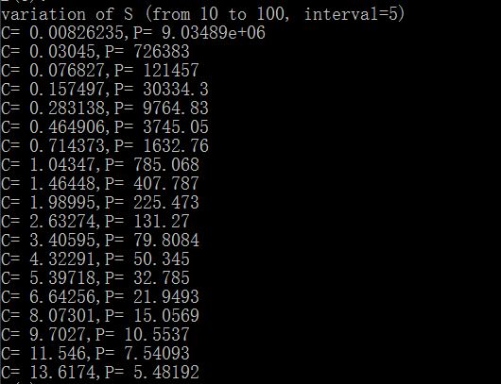

(d) K = 100, sig = 0.1, r = 0.1, b = 0.02, S = 110

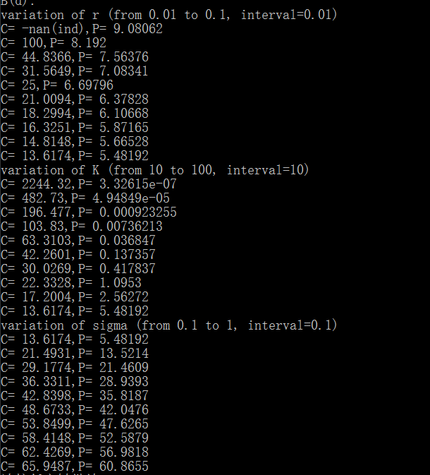

**Justifications for design decisions**

In Group A and B, there are two kinds of options, so I build two classes for each of them. For each class, I build the functions, such as computation of option and Greek (with single or multiple parameter input), for the requirement of the assignment.

Also, owing to the requirement of mesh array, I build two global functions for each of class.

Perhaps the shortcoming of my design is not using the inheritance structure as the TA’s suggestion. But, I think that there are not too many common points between these two class ( American Option class and European Option class), so that there is no need to build a base class to implement these common points. What’s more, the structure of this hw is not complex and there are just some calculations. Therefore, I decide to just build the two single classes without inheritance.